ATOMIC ENERGY CENTRAL SCHOOL 1::JADUGUDA
BUSINESS STUDIES –CLASS 12
LESSON : CONTROLLING PROCESS

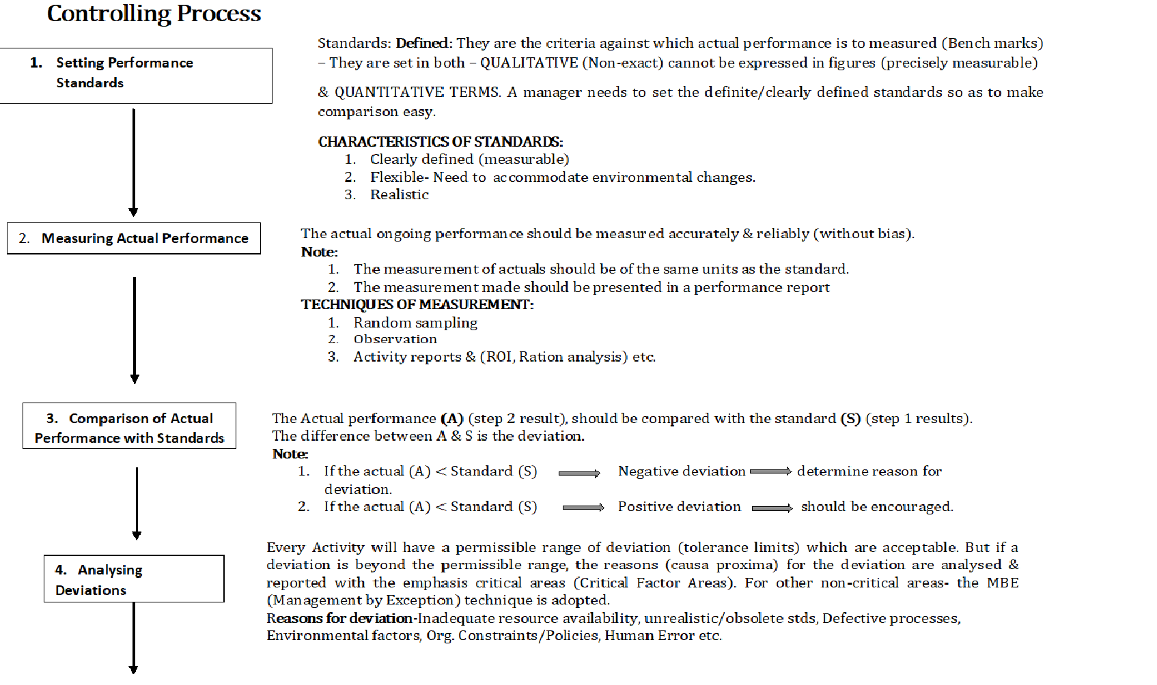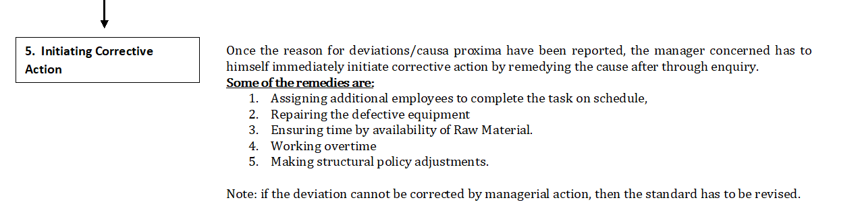

QUESTIONS:
- Explain the steps in the controlling process. ( 5 marks)
- Define deviation. (1 mark)
- ____ types of goals are not quantifiable. (1 mark)
- If an organization’s actions are not in consonance with plans, managers should take ____ action immediately. (1 mark)
- Seeking customer feedback is one way of comparing _____ with ultimate goals and standards (1 mark)
- One way of reducing ____________ from employees is for managers to include employees while setting standards and making plans. (1 mark)

